

**The Movie Store website Documentation**

|  |  |
| --- | --- |
| **Assignment Developer** | **Email Addresses** |
| Maram Bin juraied | [mbinjuraied@luc.edu](mailto:mbinjuraied@luc.edu) |

Wednesday, March 07, 2018

**Introduction:**

Today, more and more people tend to watch movies online instead of going to the theater. Movies are now considered as a form of escapism from the stresses and strains of our daily life.

From this manner, here in the movie store website I contribute in creating some entertainment to the users of the website. The user of the movie store can understand and explore the unknown in ways he/she probably never thought they could.

**WEBSITE Abstract:**

Movie Store is a website that focuses on providing information to users between 16 years old and above. It does provide the users with information about a certain movie. The users are able to do many functionalities like the follow:

1. The user is able to brows the movies on the website
2. The user can search for a certain movie
3. The user can add/remove movies from their favorite
4. The user can inquire more details about certain movie like (details, poster, votes, and cast members)

**WEBSITE Design:**

Movie Store main page will be very simple. It provides the visitor with a list of the popular movies where the user can choose one of them to have more details.

**WEBSITE Creation Tools:**

**Visual Studio IDE**: Development application to build the web application.

**Adobe Illustrator/Adobe Photoshop:** To manipulate images and to create web graphics.

**Programming Languages and framework:**

• **ASP.NET(C#) :** The web framework.

• **HTML/HTML5:** Markup language for the information that is to be displayed on a web page.

• **CSS:** Cascading style sheets for defining colors, sizes, positions of the information or HTML tags.

• **JAVASCRIPT:** For creating dynamic effects, interactive and responsive web pages.

* **Bootstrap:** Bootstrap is the most popular HTML, CSS, and JS framework for developing responsive, mobile first projects on the web.
* **The MOVIEDB API**’s: is a community built movie and TV database which provides you with different API’s where a developer can use to connect to the MOVIEDB database allowing many features to be incorporated to their website.

**Screenshots of the website:**

The website main page :

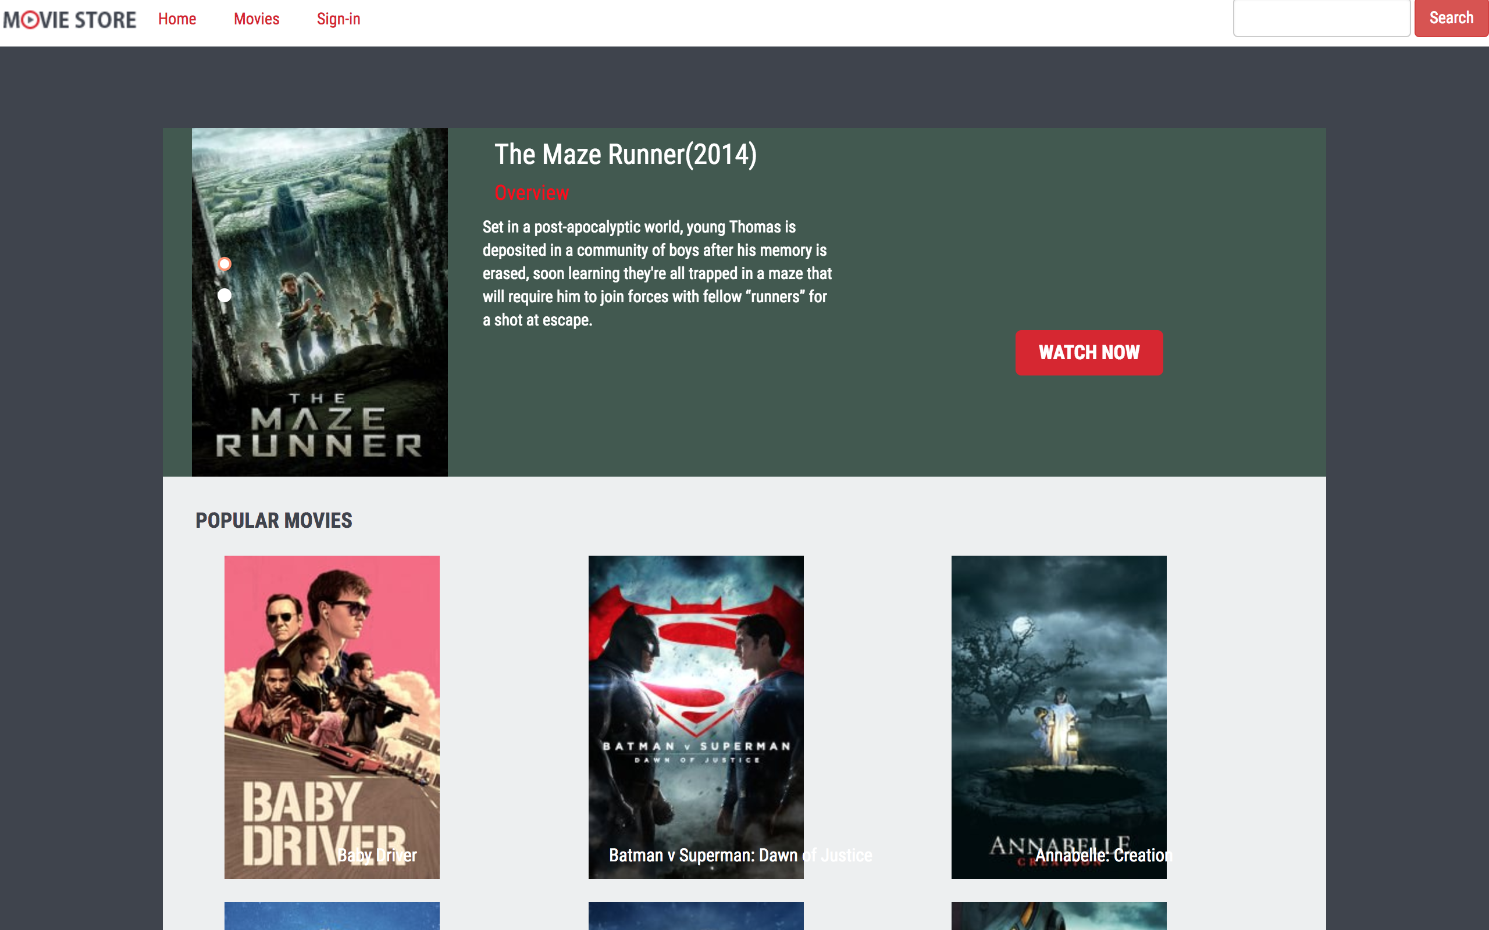

**One of the website pages:**

